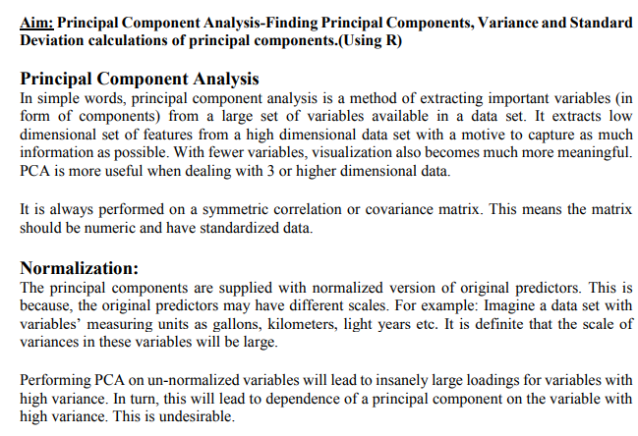

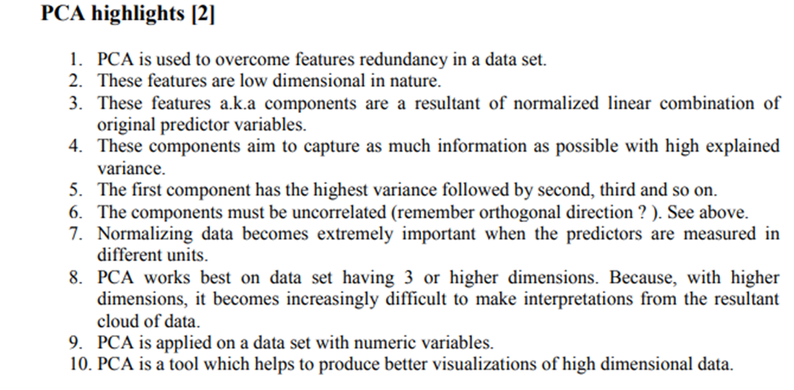

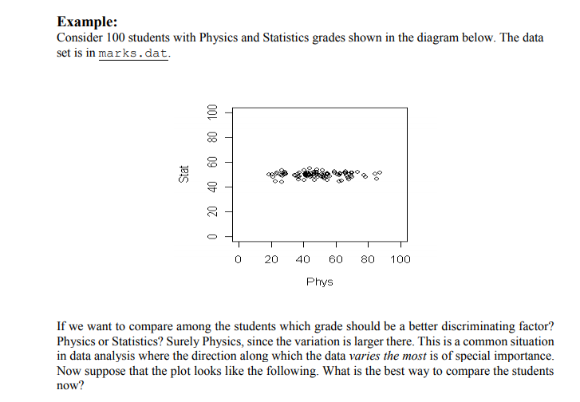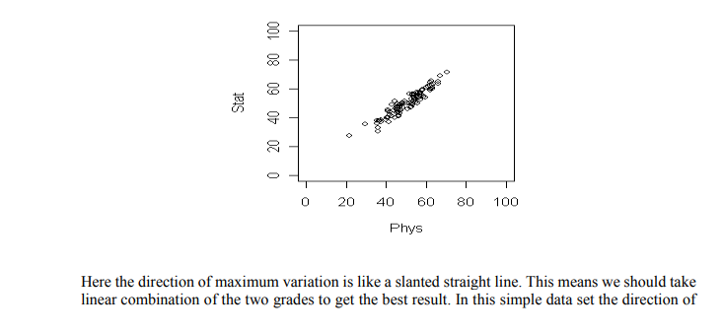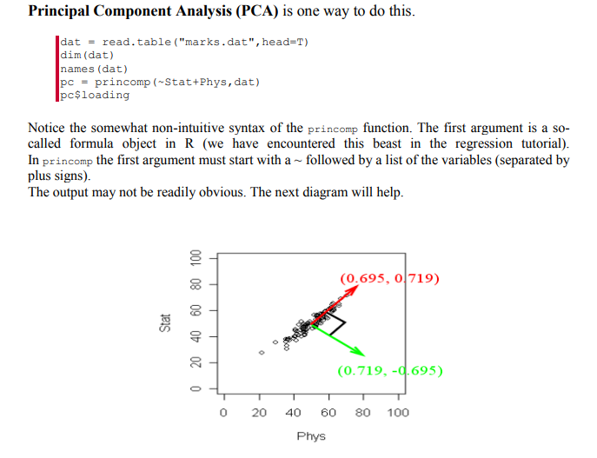

R has returned two principal components. (Two because we have two variables). These are a unit vector at right angles to each other. You may think of PCA as choosing a new coordinate system for the data, the principal components being the unit vectors along the axes. The first principal component gives the direction of the maximum spread of the data. The second gives the direction of maximum spread perpendicular to the first direction. These two directions are packed inside the matrix pc$loadings. Each column gives a direction. The direction of maximum spread (the first principal component) is in the first column, the next principal component in the second and so on.

Conclusion:

Thus we have found principal components, calculated the mean and variance of principal components.